NEG

# Public Health approach

## New Orleans PH

Andrew Ferguson, "The Rise of Big Data Policing", 2017, file:///Users/dheerjjasuja/Downloads/PP%20Book%20Chapter%203.pdf 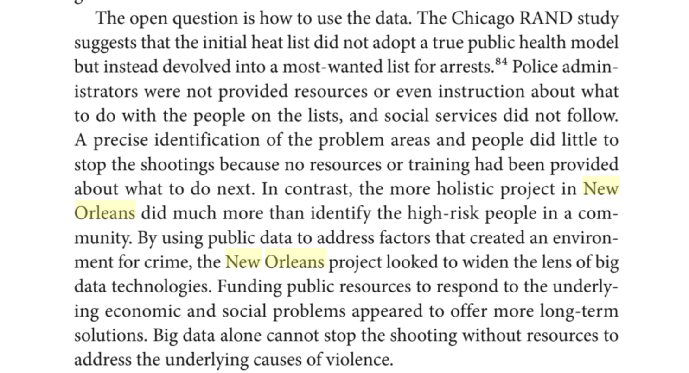

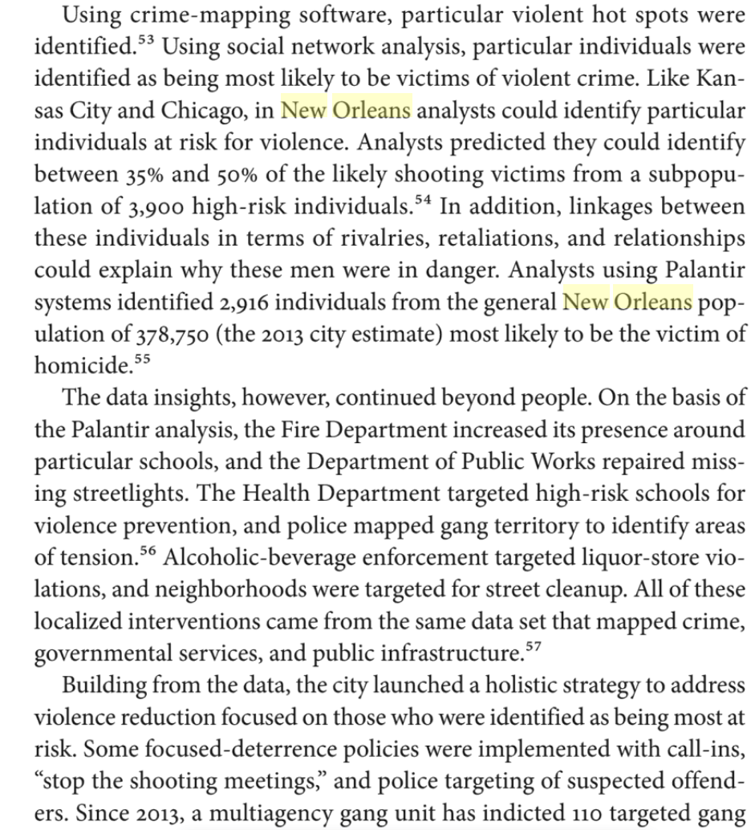

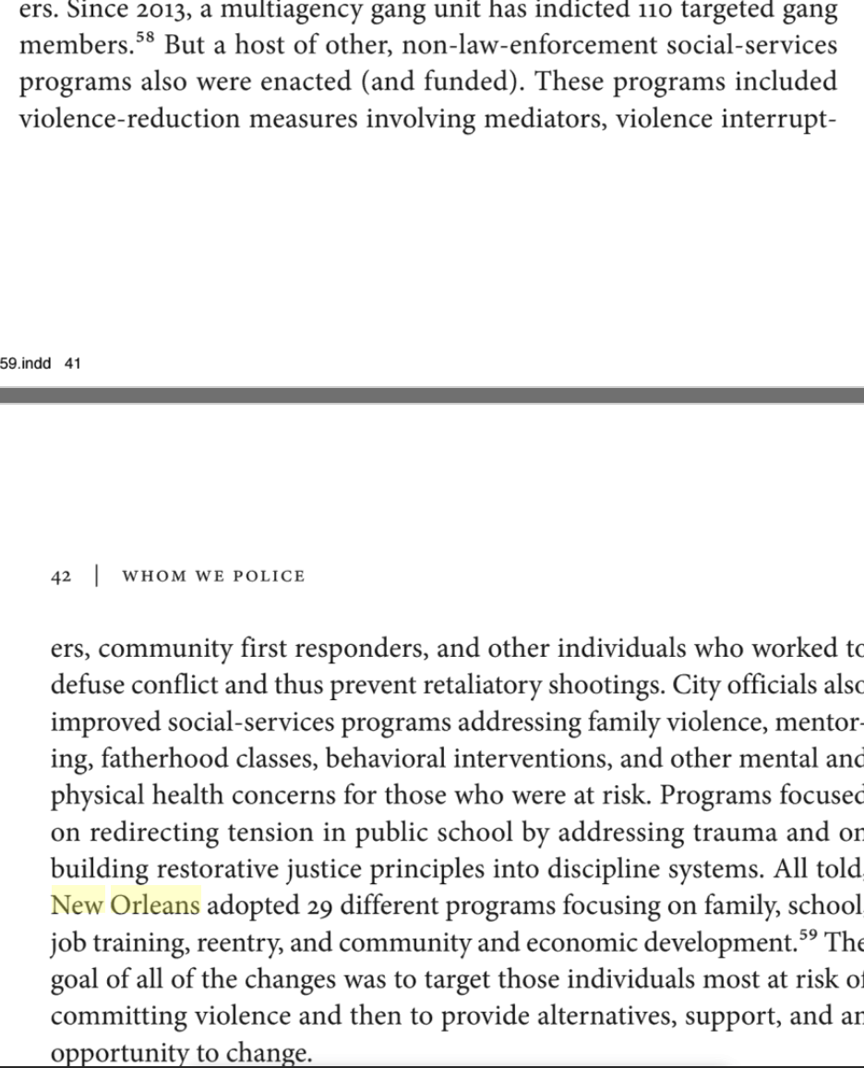

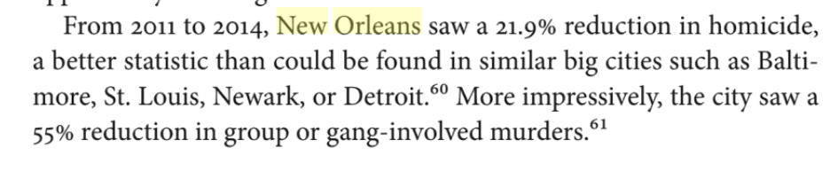

## Public Health Approach Effective in Chicago

Monica Davey, New York Times, "Chicago Police Try to Predict Who May Shoot or Be Shot - The New York Times", May 23, 2016, <https://www.nytimes.com/2016/05/24/us/armed-with-data-chicago-police-try-to-predict-who-may-shoot-or-be-shot.html>

**Miles Wernick**, a professor at the Illinois Institute of Technology, **created the algorithm**. It draws, the police say, on variables tied to a person’s past behavior, particularly arrests and convictions, to predict who is most likely to become a “party to violence.” The police cited proprietary technology as the reason they would not make public the 10 variables used to create the list, but they said that some examples were questions like: Have you been shot before? Is your “trend line” for crimes increasing or decreasing? Do you have an arrest for weapons? **Dr. Wernick said the model intentionally avoided using variables that could discriminate in some way, like race, gender, ethnicity and geography.** Jonathan H. Lewin, the deputy chief of the Chicago Police Department’s technology and records group, said: “This is not designed to replace the human process. This is just designed to inform it.**” The police have been using the list, in part, to choose individuals for visits, known as custom notifications**. Over the past three years, police officers, social workers and community leaders have gone to the homes of more than 1,300 people with high numbers on the list. Mr. Johnson, the police superintendent, said that officials were increasing those visits this year, adding at least 1,000 people. During these visits — with those on the list and with their families, girlfriends and mothers — the police bluntly warn that the person is on the department’s radar. **Social workers who visit offer ways out of gangs, including drug treatment programs, housing and job training**. “We let you know that we know what’s going on,” said Christopher Mallette, the executive director of the Chicago Violence Reduction Strategy, a leader in the effort. “You know why we’re here. We don’t want you to get killed.” Uncertain, for now, is the effectiveness. The RAND Corporation is evaluating the city’s list, but results are yet to be published. **Mr. Mallette said that 21 percent of the people they had succeeded in talking to had sought assistance, and that fewer than 9 percent had been shot since a home visit.**

# 

# PP can mitigate misconduct

The ACLU and 16 other human rights organizations note on August 31, 2016 in their coalition letter that

ACLU, "Statement of Concern About Predictive Policing by ACLU and 16 Civil Rights Privacy, Racial Justice, and Technology Organizations | American Civil Liberties Union", August 31, 2016, <https://www.aclu.org/other/statement-concern-about-predictive-policing-aclu-and-16-civil-rights-privacy-racial-justice>

**Police could use predictive tools to anticipate which officers might engage in misconduct,** but most departments have not done so. **Early experiences from Chicago and elsewhere show that police misconduct follows consistent patterns, and that offering further training and support to officers who are at risk can help to avert problems.** Police should be at least as eager to pilot new, data-driven approaches in the search for misconduct as they are in the search for crime, particularly given that interventions designed to reduce the chances of misconduct do not themselves pose risk to life and limb.

## Predictive policing can reduce bias

Hvistendahl 16 Mara Hvistendahl (contributing correspondent for Science). “Can ‘predictive policing’ prevent crime before it happens?” Science. 28 September 2016. JDN. <https://www.sciencemag.org/news/2016/09/can-predictive-policing-prevent-crime-it-happens>

Many other cities have already adopted similar systems, which incorporate everything from minor crime reports to criminals’ Facebook profiles. They’re catching on outside the United States as well. Drawing on approaches from fields as diverse as seismology and epidemiology, the algorithms can help bring down crime rates while also reducing bias in policing, their creators say. **They replace more basic trendspotting and gut feelings about where crimes will happen and who will commit them with ostensibly objective analysis.** That’s a strategy worth trying at a time when relations between U.S. police and minorities are at an all-time low, says Pittsburgh Police Chief Cameron McLay, who acknowledges that policing has a long way to go to fix bias. (Last year, McLay showed up at a New Year’s Eve celebration holding a sign that read, ”I resolve to end racism @ work.”) McLay sees **the use of big data—combined with more community-focused strategies—as part of a palliative for policing’s ills**.

# The system is changing to be more fair

Mark Puente and Cindy Chang of the LA Times find on October 17, 2016 that

Mark Puente and Cindy Chang, LA Times, "Policing Program Gets Changes in Response to Racism Claims", October 15, 2016, <https://www.latimes.com/california/story/2019-10-15/lapd-predictive-policing-changes>

PredPol was designed to predict in real time where and when crimes were likely to occur over the next 12 hours. The software’s algorithm examines 10 years of data, including the types of crimes and the dates, times and locations where they occurred. It then generates 10 “boxes,” each about 500 feet by 500 feet, designated as zones for possible property crimes such as burglaries and car thefts. **Coming changes include creating a data-driven policing unit to oversee all crime-fighting strategies** and **seeking input from various community groups before implementing new data programs.** The department also said it would **develop a system to provide periodic reports about data programs and outcomes with statistics on people and locations targeted for intervention. Officers will also stop logging on to computers to record the time they spend in the PredPol zones.** In the next few weeks, the department will finalize a manual to guide the program, Assistant Chief Robert Arcos told commissioners. Once approved and officers are trained, Arcos said he expects results can be measured in early 2020. The LAPD emphasized a “community focus” while working to reform the program, Arcos said. Moore and Arcos repeatedly pointed out that the program only predicts locations of property crimes and does not use information to identify suspects or people living in the areas where crimes could occur.

# 

# SDSC Definition

UChicago Urban Labs, University of Chicago, "Strategic Decision Support Centers | UChicago Urban Labs", 2018, <https://urbanlabs.uchicago.edu/projects/strategic-decision-support-centers>

This initiative represents a new approach to gun violence prevention that is designed to help police commanders target their resources to the right place at the right time, and be more responsive to communities' needs. **SDSCs are rooms in which a suite of technology, district leadership, and analysts trained by the University of Chicago Crime Lab work together to develop localized crime reduction strategies using data analysis, human intelligence and input from the community.**

# Terrorism

Brian Lozada, Abacus, "The Emerging Technology of Predictive Analytics: Implications for Homeland Security", 2014 <http://abacusgroupllc.com/static/pdf/TheEmergingTechnologyofPredictiveAnalytics-BrianLozada.pdf>

The emerging technology referenced in this case study will help the homeland security community in providing targeted information and developed intelligence on threats that are actively being discussed on social networks and online media sources. **The use of predictive analytics can assist in providing homeland security stakeholders with information to better prevent, prepare for, and recover from** an all-hazards event. While this technology was originally developed for private sector use, a partnership with the homeland security community can help develop a process and procedure to use predictive analytics to better safeguard the nation against **terrorist-related threats.** The emerging technology of predictive analytics is effectively transferable to a homeland security context, provided there are proper partnerships and integration into the current homeland security framework. Predictive technology will provide stakeholders within the homeland security community the information needed to make appropriate decisions regarding terrorists who have been previously profiled based on their online behavioral patterns; this will allow the homeland security community the ability to actively respond in preventing or preparing for future attacks, as the intelligence discovered may indicate motivations behind terroristrelated threats. In addition, appropriate oversight must also be established for the use of this technology so that it is not misused or misappropriated in support of the homeland security’s mission to utilize emerging technologies of this nature. From a homeland security perspective, data gathering through predictive analytic modeling can track an individual’s online search history, which can help establish trends and correlations, as well as potential areas of heightened interest to a known radical or terrorist. Once this information is collected and time-stamped, homeland security agencies can actively monitor these individuals’ whereabouts, through the analysis of GPS data, and behaviors, through the analysis of semantic patterning, to potentially mitigate a planned attack. In addition, this technology can be used to analyze and apply internet traffic patterns to determine potential reconnaissance that terrorists are plotting, as well as possible methodologies that terrorists are researching, in order to launch successful attacks against our nation.

## This system is sound in practice.

Kathleen McKendrick of Chatham House—a British Think Tank—noted in August 2019

Kathleen McKendrick, Chatham House, "Artificial Intelligence Prediction and Counterterrorism", August 2019, <https://www.chathamhouse.org/sites/default/files/2019-08-07-AICounterterrorism.pdf>

Leaked details of **the** **US National Security Agency’s SKYNET**, which was purportedly used in Pakistan in 2007, are useful in illustrating how quantitative methods might predict involvements in terrorism. As reported, the **algorithm was used to analyse metadata from 55 million domestic Pakistani mobile phone users.**38 This was a machine learning model built by exposure to those data; **it classified the phone users into two separate groups, one of which exhibited a usage pattern matching that of a small group of persons known to be terrorist couriers, the other comprising the remainder of the mobile phone users. T**he model was able to narrow the large population size down, and was reported to have **falsely identified individuals as potential [terrorist] couriers in only 0.008 per cent of cases**. It is important to note, however, that the scale of the initial dataset in relation to the total population of Pakistan (at that time approaching 200 million) implies that **a false positive rate of 0.008 per cent** would result in the wrongful identification of some 15,000 individuals as of interest. Furthermore, the 0.008 per cent false positive rate could only be achievedwith a 50 per cent accuracy rate for identifying known couriers, meaning that half of the known couriers could be identified using the model. From **these figures**, it is obvious that the model used was not effective in its own right, but it **show**s **how seemingly non-sensitive data may have predictive value when identifying close links with terrorism or likely intelligence value**. These limited examples of cases of the use of predictive AI in countering terrorism hint at the possibilities, rather than providing any credible proof of concept. It is not realistic to expect AI to provide immediate solutions to complex questions. US Immigration and Customs Enforcement discovered this when attempting to use machine learning models in data mining across various internet sources to assist with the vetting of visa applicants. The pursuit of a technical solution to this task was abandoned after it became clear that no such capability was available for immediate procurement.39 In summary, there are already numerous examples of AI that predict terrorism, or aspects of terrorism. Often, the ability to develop AI tools for this purpose rests with those who have access to data, or who are custodians of it by virtue of the service they provide. Where predictive AI is useful to police forces and other authorities (such as border enforcement agencies), its development is often outsourced to the software industry. **Assuming that the trend of digitization continues, and that the performance of AI improves, there will be more scope to derive accurate predictions about terrorism from AI in future, and its uptake for counterterrorism use is likely to increase**.

## Al Qaeda killed 4000 people

Statista Research Department, Statista, "Terrorist attacks of the Al-Qaeda by death toll 1993 to 2010 | Statista", May 2011, <https://www.statista.com/statistics/272757/al-qaeda-terrorist-attacks-by-death-toll/> 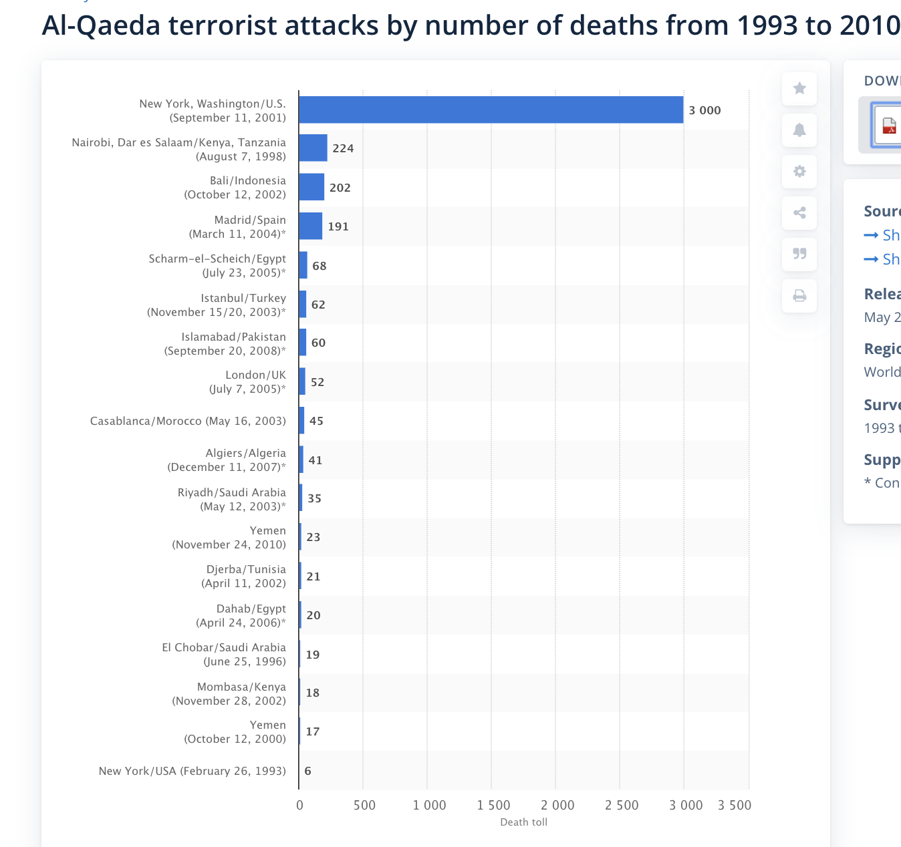

# 

# Many Results from PP

“Proven Results of Our Predictive Policing Software.” *PredPol*, 2017, [www.predpol.com/results/](http://www.predpol.com/results/).

**The Los Angeles Police Department’s Foothill Division saw a 20% drop in predicted crimes** year over year **from January 2013 to January 2014** and experienced a day without crime on February 13, 2014. In Los Angeles’ Foothill Division, crimes were down 13% in the 4 months following the rollout compared to an increase of 0.4% in the rest of the city where the rollout had not happened. Over this time period Foothill Division was a leader in crime rate reduction among LAPD’s divisions. Similar reductions have been seen in other cities that implemented the tool. During Atlanta’s initial launch, aggregate crime decreased by 8% and 9% in the two areas that first deployed PredPol in July 2013. Of the four zones where PredPol was not deployed, crime rates increased by 1 to 8% in three and remained flat in one. Due to these successful results, the Atlanta Police Department decided to implement PredPol citywide in November 2013**. Atlanta Police Department has seen aggregate crime drop 19% and attribute much of the sustained reduction to PredPol’s deployment. The Alhambra, CA Police Department reported a 32% drop in burglaries and a 20% drop in vehicle theft since deploying in January 2013.** The city reported its lowest month of crime in history in May 2014. **The Norcross, GA Police Department has** had a 15-30% reduction in burglaries and robberies just four months after deploying in August 2013, and Captain Bill Grogan has **stated that predicted crime is down 22.7%** when comparing 10 months using PredPol to the same 10 months before using PredPol. **The Modesto, CA Police Department recently reported** the lowest crime rates in 3 years since deployment in January 2014, including **an 18% reduction in residential burglary and a 13% reduction in commercial burglary. The Santa Cruz, CA Police Department saw** assaults drop by 9%, burglaries decrease by 11%, and robberies down 27% in its first year using the software (2011-2012). **Crime overall dropped 25% in June 2013 and 29% in July 2013 compared with those same months the previous year.** Helping to Reduce Municipal Costs **Reductions in crime from predictive policing save law enforcement, courts, jails, and communities hundreds of thousands to millions of dollars per year.** While crime reduction statistics differ from community to community, a jurisdiction that experiences a 20% crime reduction translates to 20% less time filling out reports and 20% less time in court, freeing officers up to spend more time policing on the beat and engaging in their communities.

## Meta-data show PP is good

Center for Evidence-Based Crime Policy. “What is Hot Spots Policing?” 2016. JDN.

<https://cebcp.org/evidence-based-policing/what-works-in-policing/research-evidencereview/hot-spots-policing/>

The evidence base for hot spots policing is particularly strong. As the National Research Council (2004: 250) review of police effectiveness noted, “studies that focused police resources on crime hot spots provided the strongest collective evidence of police effectiveness that is now available.” A Campbell systematic review by Braga et al. (2012) comes to a similar conclusion; although not every hot spots study has shown statistically significant findings, the vast majority of such studies have **20 of 25 tests from 19 experimental or quasi-experimental evaluations reported noteworthy crime or disorder reductions, suggesting that when police focus in on crime hot spots, they can have a significant beneficial impact on crime in these areas.**

## 

## 

## 

## 6 cases where PP saved lives in New Delhi (total 9 lives and 15 arrested)

Times of India, "Delhi's tryst with predictive policing | Delhi News - Times of India", June 15, 2018, <https://timesofindia.indiatimes.com/city/delhi/delhis-tryst-with-predictive-policing/articleshow/64598386.cms>

What is pre-crime It refers to law enforcement efforts and strategies to deter crime by predicting when and where [criminal activity](https://timesofindia.indiatimes.com/topic/criminal-activity) will occur. Origin of pre-crime The term was coined in 1956 by [Philip K Dick](http://timesofindia.indiatimes.com/topic/Philip-K-Dick) in his science-fiction short story, The Minority Report 6 Cases where [science fiction](https://timesofindia.indiatimes.com/topic/science-fiction) met reality

1. **June 12, 2018** PLOT | Man comes out on a one-week parole; plans to kill an industrialist (78) and his wife (75) apart from another [murder](https://timesofindia.indiatimes.com/topic/murder-case) witness on the last day and return to jail. Discusses plan with girlfriend, cops arrest them hours before the murders. **Lives saved | 3 Arrested | 2** 2. **May 30, 2018** PLOT | Nursing attendant of an elderly couple aged 92 and 85 hatches a plot to kill them and rob their house on his last working day. Discusses plan with a weapon supplier, gets busted while en route to commit the murders. **Lives saved | 2 Arrested | 1 3. March 24, 2018** PLOT | D-Company’s men send shooters to kill Wasim Rizvi, president of Sunni Waqf Board. Special Cell manages to reach the spot in the nick of time and busts the plot. **Life saved | 1 Arrested | 5 4. Mar 7, 2018** PLOT | Cops avert the murder of a woman named Bhavna, a witness to a murder committed by a gang led by a criminal named Rocky **Life saved | 1 Arrested | 2 5. June 7, 2017** PLOT | On D-Company’s instructions, a local gang is at the end-stage of a plot to eliminate a Bajrang Dal activist to ignite communal tension; busted **Life saved | 1 Arrested | 3 6. Dec 9, 2017** PLOT | A gang arrives at a police station in northeast Delhi to gun down a rival who’s in custody. Tracking them, cell foils the plan **Life saved | 1 Arrested | 3**

## 

## Don’t use PP worked in Santa Cruz, Foothill LA, Englewood Chicago

## 

Zach Friend, FBI LEB, "Predictive Policing: Using Technology to Reduce Crime — LEB", April 9, 2013, <https://leb.fbi.gov/articles/featured-articles/predictive-policing-using-technology-to-reduce-crime>

During the first 6 months of the program, the department made over 2 dozen arrests within the hot spot locations. However, the true measure of the program’s success is not apprehensions, but the reduction of crime. **Santa Cruz** police officers indicated an initial 11 percent reduction in burglaries and a 4 percent decrease in motor vehicle thefts. As time progresses, the reductions increase. **Over a 6-month period, burglaries declined 19 percent.** The system requires 6 months of data to assess whether the method actually is reducing the crime rate. **Because the Santa Cruz police did not introduce any additional variables**—no additional officers were hired, shift lengths continued, patrol structure remained the same—**the department attributed the crime reduction to the model. The Los Angeles Police Department (LAPD) tested the method under a controlled experiment**. The project scientifically proved the model’s effectiveness. The city has a larger population and more complex patrol needs than Santa Cruz. Researchers established the experiment **in** the **Foothill** Division with a population of 300,000 people. They compared the predictive policing system with LAPD’s best practices. Similar to the Santa Cruz test, the department distributed maps to officers at the beginning of roll call. On some days analysts produced the maps using traditional LAPD hot spot methods. On other days, they used the algorithm. No one told the officers where the maps came from. Graphically they looked the same. The algorithm provided twice the accuracy that LAPD’s current practices produced. **While property crime was up .4 percent throughout Los Angeles, Foothill’s declined by 12 percent**. **Foothill benefitted from the largest crime reduction of any division during the experiment.**

The Economist, "Serve and predict - Violent crime is down in Chicago | United States | The Economist", May 5, 2018, <https://www.economist.com/united-states/2018/05/05/violent-crime-is-down-in-chicago>

Policing software such as Predpol or HunchLab, their makers claim, is able to forecast where crime is likely to be committed. Certainly the numbers are intriguing. After **2016 turned out to be the deadliest year for two decades**, with 762 murders and 3,550 shootings, **the following year, which coincided with the establishment of the first SDSC, was less bloody**, with 650 murders and 2,785 shootings. The decline in crime in police districts with the new data centres was steeper than in those without. This could just have been reversion to the mean. But the Chicago police department thinks that HunchLab, the particular program it bought, has something to do with it. To see why this might be the case, **consider Englewood [Chicago]. A hard-up, predominantly black neighbourhood on the South Side, Englewood saw a decline in murders of 44% in 2017 compared with 2016. Shootings fell by 43%.** A byword for concentrated poverty, rampant crime, drugs, guns and gangs, Englewood seems to have taken everyone by surprise with its progress. Laura West, an officer working at the district’s SDSC, which is staffed by two officers at all times, spends her days surrounded by screens. One shows a program called ShotSpotter, which uses the sound of gunfire to pinpoint shootings; another shows where surveillance cameras are (the city has more than 40,000); and a third displays HunchLab software. This blends data on crime statistics, population density and weather patterns with fixed points such as liquor stores and highway exit-ramps, to identify patterns of crime that may repeat themselves. (Predictive policing software also takes into account the phases of the moon and the schedules of sports games.) At-risk sites are marked with boxes colour-coded according to the type of crime. Patrol officers are encouraged to check them frequently. **The key to Englewood’s improvement has not been more aggressive policing, says Kenneth Johnson, the district commander.** “We cannot arrest our way out of our problems,” he says. **Instead**, as he tells it, **the change is the result of targeted interventions**, combined with improved relations with the local community. The CPD’s relationship with black Chicagoans in particular has long been fraught. Its recent nadir was a white officer’s seemingly wanton firing of 16 bullets into Laquan McDonald, a black teenager, as he was walking away. The officer, Jason Van Dyke, who is about to be tried for first-degree murder, had been the subject of numerous complaints. Changing such a culture will take time. In Englewood, Mr Johnson tells his 350 officers to attend community meetings, to build relationships and to avoid behaving like an occupying force.

## 

## Deterrent + How PredPol works

Issie Lapowsky, Wired, "How the LAPD Uses Data to Predict Crime", May 22, 2018, <https://www.policechiefmagazine.org/product-feature-predictive-policing-helps-law-enforcement-see-around-the-corners/>

In addition to LASER, the LAPD is also using a piece of software called PredPol to predict property crimes. It looks at the types of crimes that were committed in a given area, the time, and the location, and determines whether and when another crime is likely to occur there. PredPol then spits out maps, which are updated daily, marked with 500-by-500 foot hotspots that officers are strongly encouraged to patrol. “When you see more police officers, you see the lights, you hear the sirens, **the high visibility of officers does deter crime in certain areas,”** says Officer Steve Núñez, who has been with the LAPD’s Foothill division for 16 years. He argues that **just circling the block in some of these hotspots can serve as a deterrent in high-crime areas**.

# Money

## ETAS projected to save money in LA

Mohler et al 15

G. O. Mohler (Department of Mathematics and Computer Science, Santa Clara University), M. B. Short (School of Mathematics, Georgia Institute of Technology), Sean Malinowski (Los Angeles Police Department), Mark Johnson (Kent Police Service), G. E. Tita

(Department of Criminology, University of California, Irvine), Andrea L. Bertozzi (Department of Mathematics, University of California, Los Angeles), P. J. Brantingham (Department of Anthropology, University of California, Los Angeles), and Peer Reviewed.

“Randomized controlled field trials of predictive policing.” Journal of the American Statistical Association, 110(512). October 2, 2015. <https://www.researchgate.net/publication/282772661_Randomized_Controlled_Field_Trials_of_Predictive_Policing>

Much depends on how representative the practices of the Los Angeles and Kent Police Department are in the broader policing world. While there is considerable tactical and strategic variation in policing practice across departments, the use of of crime mapping, hotspot maps, and simple criminal intelligence to identify chronic offenders is as close to universal as anything. In a survey of US police departments, for example, **100% of departments serving populations of 500,000 people or more relied regularly on these analytical methods** [15, 41]. The proportion of police departments falls to 56% for those serving populations of 50,000-100,000. Police departments in England and Wales ranked crime mapping in support of intelligence-led policing at the top of the analytical tasks the perform as a proportion of time [52]. The comparison of algorithmic predictions to best practices in intelligence-led and hotspot mapping by two prominent departments therefore would seem to have reasonable external validity especially as department size increases. More challenging is an assessment of whether similar effect sizes can be expected in other settings. Comparisons between regions based on existing studies are problematic [2]. Tables 1 and 2 show that area standardized accuracies (PAI) across regions vary widely. In the present study area-standardized accuracies range from 3.5 to 85.2 for ETAS and 1.2 to 50.8 for analysts in Southwest and Maidstone, respectively. Variation in area-standardized accuracies is driven by differences in the physical sizes of the regions in question [47], the mixtures of crimes included in predictions [9], and the time scales over which predictions are rendered [47]. Comparison of the relative performance of different forecasting methods within regions helps solve some of these problems. Since different forecasting methods tested within a region are subject to the same constraints of physical area, mix of crimes, and forecasting time scales, the gap between their performance is less subject to such confounding factors. This is the approach followed by [9] where kernel density estimation yields an average boost over other hotspotting methods of 1.7 to 1.8. As shown here and in [36], ETAS provides a boost over kernel density estimation, providing a basis for positing an expected magnitude of results elsewhere. Ultimately, whether this hypothesis proves true is an empirical question that will require further experimental and comparative work. Beyond the question of broader applicability, we might also ask whether the observed impact on crime is significant as a practical matter. At mean patrol levels (31 minutes per box per day), the **ETAS algorithm corresponds to 4.3 fewer crimes per week per division. While a crime reduction of 7.4% may appear small, the potential savings to society are quite large** when estimated using the methodology of McCollister, French and Fang [34]. In Table 8 we display the societal costs per crime calculated in [34], broken down by costs to the victim, police and court system, and offender (2013 dollars). We then use the relative frequencies of GTA, burglary theft from motor vehicle, and burglary (.292, .584, .184) along with the average crime rate per LAPD division at zero patrol levels to estimate the weekly cost of crime per division without predictive policing (Table 9). We then estimate the savings per week achieved by a 4.3 crime reduction per division on average and extrapolate the savings across LAPD. **We project a $17,258,801 annual savings to LAPD if ETAS were to be used for 31 minutes per day in each hotspot compared to no patrol.** Patrols allocated under analyst conditions are projected to achieve less than half the half the savings ($8,223,519).

## 

## Crime Reduction and Savings in Memphis + Lancaster

Scott Harris, “Product Feature: Predictive Policing Helps Law Enforcement ‘See Around the Corners’,” The Police Chief (October 2014): 44–45. <https://www.policechiefmagazine.org/product-feature-predictive-policing-helps-law-enforcement-see-around-the-corners/>

The city of **Memphis**, Tennessee, **saw a 28 percent reduction in serious crime and achieved an 863 percent return on their investment.** **Lancaster**, Pennsylvania, **reduced its crime by 42 percent over four years while saving an estimated $134 million.**

## 

## Crime down + Savings in Richmond

Beth Pearsall (freelance writer and frequent contributor to the NIJ Journal). “Predictive

Policing: The Future of Law Enforcement?” NIJ Journal / Issue No. 266. June 23, 2010.

<http://stateexempt.com/predictivepolicing.pdf>

Here are two examples of predictive policing at work: Reducing Random Gunfire in Richmond. Every New Year’s Eve, Richmond, Va., would experience an increase in random gunfire. Police began looking at data gathered over the years, and based on that information, they were able to anticipate the time, location and nature of future incidents. On New Year’s Eve 2003, **Richmond police placed officers at those locations** to prevent crime and respond more rapidly. The result was a **47 percent decrease in random gunfire and a 246 percent increase in weapons seized. The**

**department saved $15,000 in personnel costs.** Connecting Burglaries and Code Violations in Arlington, Texas. The Arlington, Texas, Police Department used data on residential burglaries to identify hot spots and then compared these locations to areas with code violations. According to Chief Theron Bowman, officers found that every unit increase of physical decay resulted in almost six more residential burglaries in the city. Thus, neighborhoods with greater physical decay could expect greater increases in residential burglaries. Arlington subsequently developed a formula to help identify characteristics of these “fragile neighborhoods.” The police department and other city agencies now work more efficiently in the neighborhoods to help prevent crime.

## 

## Palantir costs only $3 million

Winston, Ali. “Palantir Has Secretly Been Using New Orleans to Test Its Predictive Policing Technology.” *The Verge*, The Verge, 27 Feb. 2018, [www.theverge.com/2018/2/27/17054740/palantir-predictive-policing-tool-new-orleans-nopd](http://www.theverge.com/2018/2/27/17054740/palantir-predictive-policing-tool-new-orleans-nopd).

According to [emails](https://www.documentcloud.org/documents/4377436-Chicago-PD-Palantir-emails.html) obtained by *The Verge*, **Palantir marketing staff** first **contacted the Chicago Police Department** in late 2013 **about** the possibility of **selling a predictive policing package based on** the firm’s **New Orleans work**, **eventually settling on a $3 million price tag.** Through a series of federal grants awarded to CPD beginning in 2009, Chicago Police and academics at the Illinois Institute of Technology had already created their own crime-forecasting program that assigned a risk score to individuals based on criminal data and social media histories.

# 

# AT China

China does not use PP, uses mass surveillance

Maya Wang, Human Rights Watch, "China’s Algorithms of Repression | Reverse Engineering a Xinjiang Police Mass Surveillance App", May 1, 2019, <https://www.hrw.org/report/2019/05/01/chinas-algorithms-repression/reverse-engineering-xinjiang-police-mass-surveillance>

**Analysis of the IJOP app reveals that authorities are collecting massive amounts of personal information—from the color of a person’s car to their height down to the precise centimeter—and feeding it into the IJOP central system,** linking that data to the person’s national identification card number. Our analysis also shows that Xinjiang authorities consider many forms of lawful, everyday, non-violent behavior—such as “not socializing with neighbors, often avoiding using the front door”—as suspicious. The app also labels the use of 51 network tools as suspicious, including many Virtual Private Networks (VPNs) and encrypted communication tools, such as WhatsApp and Viber. The IJOP app demonstrates that Chinese authorities consider certain peaceful religious activities as suspicious, such as donating to mosques or preaching the Quran without authorization. But most of the other behavior the app considers problematic are ethnic-and religion-neutral. **Our findings suggest the IJOP system surveils and collects data on everyone in Xinjiang.** **The system is tracking the movement of people** by monitoring the “trajectory” and location data of their phones, ID cards, and vehicles; it is also monitoring **the use of electricity and gas stations** of everybody in the region. This is consistent with **Xinjiang local government statements that emphasize officials must collect data for the IJOP system** in a “comprehensive manner” from “everyone in every household.” When the IJOP system detects irregularities or deviations from what it considers normal, such as when people are using a phone that is not registered to them, when they use more electricity than “normal,” or when they leave the area in which they are registered to live without police permission, **the system flags these “micro-clues” to the authorities as suspicious and prompts an investigation.**

## 

## Brantingham study idk how to use

Jeffrey Brantingham et. al., Statistics and Public Policy, "Does Predictive Policing Lead to Biased Arrests? Results From a Randomized Controlled Trial: Statistics and Public Policy: Vol 5, No 1", Feb 8, 2018, <https://www.tandfonline.com/doi/full/10.1080/2330443X.2018.1438940?scroll=top&needAccess=true>

The stated goal of the analyses presented above was to assess the degree to which arrest rates were impacted by the introduction of predictive policing in three divisions patrolled by the LAPD. Special attention was paid to arrest rates by the race-ethnicity of the individuals detained. Our null hypotheses were: (1) arrest of minority individuals did not differ between control and treatment conditions in test divisions; (2) arrest rates overall did not differ between control and treatment conditions in test divisions; (3) the rate of arrests per crime was unchanged across treatment and control conditions. The evidence presented does not allow us to reject null hypothesis (1). **There is no significant difference in the arrest proportions of minority individuals between treatment and control conditions**. We also cannot reject hypothesis (2) at the division level. Arrest rates overall are the same on control and treatment days within the test divisions as a whole. However, we do reject null hypothesis (2) at the box level. Arrests were higher overall in treatment prediction boxes. We therefore tested hypothesis (3) to see if the higher arrest rate in treatment boxes is explained by an overall higher crime rate in treatment boxes. We fail to reject the null hypothesis (3). **Arrest rates per crime do not differ across treatment and control conditions.** Clearly, arrests are a common part of day-to-day police operations. The introduction of predictive policing did not increase arrests overall, though treatment prediction boxes did see significantly more arrests than control prediction boxes. **The increase arrests in treatment prediction boxes are perhaps understandable given that algorithmic crime predictions are more accurate than those produced by existing best practice** (Mohler et al. 2015). The present study has several important limitations. Arrests are an imperfect proxy for other types of police contacts including stops, searches and detentions short of arrest. It is possible that predictive policing induced increases in these other categories of police contacts, without a concomitant impact on arrests. For this to hold true, it would have to be the case that the rate of arrest actually declined as these other precursor contacts increased, leaving overall arrest numbers unchanged. This hypothetical downward adjustment in arrests would have to hold not only for the experimental deployment period overall, but also for randomly assigned treatment days. We do not have sufficient data to exclude such dynamics, but they seem improbable on the face of it. Second**, the analyses do not provide any guidance on whether arrests are themselves systemically biased.** Such could be the case, for example, if black and Latino individuals experienced arrest at a rate disproportionate to their share of offending (Rosenfeld and Fornango 2014). The current study is only able to ascertain that arrest rates for black and Latino individuals were not impacted, positively or negatively, by using predictive policing. Future research could seek to test whether the situational conditions surrounding arrests and final dispositions differ in the presence of predictive policing.

# 

# AT: Police stopped using PP

## AT: NOLA stopped

Cantrell et. al., New Orleans Municipal Government, "Forward Together New Orleans Transition Report Mayor-Elect Latoya Cantrell", 2018, <https://irp-cdn.multiscreensite.com/a41e72e5/files/uploaded/ForwardTogetherTransitionPlan.pdf>

**A hiring freeze led to an almost crippling staffing shortage.** While the recruitment process has been streamlined and applications are at an all-time high, **bottlenecks in the Civil Service hiring process slow down hiring, producing chronic shortfalls of the projected officer numbers required to maintain public safety.** Currently, **only 3 percent of applicants successfully make it through the process.** In 2017, NOPD experienced its lowest attrition rate in 20 years; nevertheless, **retention concerns remain**. New crime-fighting initiatives, including partnerships with other law enforcement agencies, have achieved **results**. However, these **are difficult to scale given resources, operational capacity,** and Consent Decree considerations. Investments in technology and analytics have been made and deployed, but further resources and training are needed to maximize efficiency and effectiveness throughout the Department.

## AT: Kent Stopped

BBC, "Kent Police stop using crime predicting software - BBC News", November 26, 2018, <https://www.bbc.com/news/uk-england-kent-46345717>

The software, created by US firm PredPol, was **introduced** across the county in **April 2013** after a four-month trial in Medway saw street violence fall by 6%.It uses past trends and current information to predict when and where crime is likely to happen. Crime increased in the first year of its use, although police admitted at the time this was because officers did not know how to use the software. 'Really useful’ **Kent Police Federation chairman Chris Carter said the software was useful for "proactive" policing, but said "officers have got less time to use it" due to increasing crime and decreasing resources.** "When I was a neighbourhood inspector it was really useful to me," he said.

# 

# Policing even minor crimes is valuable—it prevents escalation to violent crimes

Hvistendahl 16

Mara Hvistendahl (contributing correspondent for Science). “Can ‘predictive

policing’ prevent crime before it happens?” Science. 28 September 2016. JDN.

<https://www.sciencemag.org/news/2016/09/can-predictive-policing-prevent-crime-it-happens>

Like PredPol, Pittsburgh’s CrimeScan program has a geographic focus, but it draws on a broader variety of indicators. Gorr and Neill took their inspiration from criminology research showing that **criminals tend to be generalists, and they tend to progress from minor to more serious crimes.** As a result, the duo hypothesized, reports of minor crimes could help predict potential flare-ups of violent crime. In a gang confrontation, Neill says, ”maybe it starts out with harsh words and offensive graffiti, and turns into fist fights, which turn into shootings, which turn into lots of shootings.” Along with observations from the recent past, CrimeScan incorporates scores of minor crime offenses and 911 calls—about things like disorderly conduct, narcotics, and loitering—to spit out predictions about city blocks likely to see upsurges in violent crime in the next few days or weeks.

# 

# AT: Random Patrol

Mohler et al 15

G. O. Mohler (Department of Mathematics and Computer Science, Santa Clara University), M. B. Short (School of Mathematics, Georgia Institute of Technology), Sean Malinowski (Los Angeles Police Department), Mark Johnson (Kent Police Service), G. E. Tita

(Department of Criminology, University of California, Irvine), Andrea L. Bertozzi (Department of Mathematics, University of California, Los Angeles), P. J. Brantingham (Department of Anthropology, University of California, Los Angeles), and Peer Reviewed.

“Randomized controlled field trials of predictive policing.” Journal of the American Statistical Association, 110(512). October 2, 2015. <https://www.researchgate.net/publication/282772661_Randomized_Controlled_Field_Trials_of_Predictive_Policing>

Crime events arise out of interactions between local, place-based environmental conditions [5, 53] and the situational decision-making of offenders and victims [33, 24]. In

theory, police patrol can prevent crime on a day-to-day basis by altering or disrupting the environmental conditions suitable for crime [42, 54]. However, experimental studies

attempting to measure the effectiveness of different police patrol strategies show mixed results [12, 3]**. Random patrol has a negligible impact** [25] b**ecause the risk of crime is not uniformly distributed in space or time** [43, 20]. Random patrol therefore allocates resources to locations that have little or no associated crime risk. **Hotspot policing**, by contrast, **concentrates** overwhelming **resources in** direct **response to non-uniform crime patterns** [44], l**eading to crime suppression** not only at deployment locations, but also

over a surrounding region through a diffusion of benefits [17]. Displacement of offenders appears to be incomplete in both theory [45] and practice [55, 40], indicating that **hotspot policing produces a net reduction in crime**

# 

# AT: Crime across India up

Vidushi Marda and Shivangi Narayan, Association for Computing Machinery, "Data in New Delhi's predictive policing system", January 2020, <https://dl.acm.org/doi/pdf/10.1145/3351095.3372865>

**As of 2019, law enforcement agencies across India are in the process of deploying machine learning systems for crime prevention,criminal tracking, and better allocation of resources.** In Chennai, one of the major Indian metropolises with a population of 11 mil-lion, facial recognition systems are deployed in crowded places to identify criminals and individuals who “look suspicious” [18]. Inthe south Indian state of Telangana (estimated population of 40million) smart law enforcement has come to be deployed with a view to create a “360 degree view” of citizens [28]. Elsewhere, in the north Indian state of Punjab (estimated population of 30 million),the Punjab Artificial Intelligence System received a Smart PolicingAward for its use of facial recognition in crime solving [30]. The Na-tional Crime Records Bureau of India recently published a tender for the Automated Face Recognition System which would be used for“criminal identification, verification and its dissemination among various police organizations and units across the country” [16]. One of the first initiatives towards the use of machine learning (ML) inlaw enforcement was pioneered by the Delhi Police. For context,Delhi is a city with a population of close to 30 million people.

e

<https://blogs.scientificamerican.com/voices/how-to-fight-bias-with-predictive-policing/>

<https://www.innefu.com/blog/benefits-of-predictive-policing/>

**Chen Quanguo Party Secretary China Does Not call it predictive policing**

"China’s Algorithms of Repression | Reverse Engineering a Xinjiang Police Mass Surveillance App", Wed Mar 04 2020, https://www.hrw.org/report/2019/05/01/chinas-algorithms-repression/reverse-engineering-xinjiang-police-mass-surveillance

We must respond to the new ways in which hostile forces and terrorists are plotting crimes by implementing all-encompassing, round-the-clock, three-dimensional prevention and control [surveillance systems], to resolutely ensure that there are no blind spots, no gaps, no blanks unfilled [in our efforts]. —Chen Quanguo, Xinjiang party secretary, in a directive issued on August 17, 2017[9]